Ein Bild, das Person, haltend, Mann, Mobiltelefon enthält.
VoCa

 A Vocabulary learning App

Mockup resource nr. 1

I welcome you to follow me on my journey on designing an app for vocabulary learning

Tools I used in this project:

* [Marvel App](https://marvelapp.com/)
* [Edraw Max](https://www.edrawsoft.com/)
* Adobe [XD](https://www.adobe.com/at/products/xd.html)​​​​​​​​​​​​​​ & [Photoshop](https://www.adobe.com/at/products/photoshop.html)
* Apple Keynote & Numbers

About the project

VoCa is the first project I have worked on in my UX Design Course at Careerfoundry and it was the graduation project of the fundamentals part of the course.

The project goal was to create a mobile vocabulary learning app from scratch. This took me on a journey, diving into the iterative process of Design Thinking, UX Design best practices and learning new tools.

VoCa is designed to support people, eager to learn new vocabulary while they are on the go, making the most of their time spent commuting to school, university or work. The newly learned vocabulary will support their private and professional goals, by giving them the confidence to articulate and write in the best way possible.

The problem

Learning a new language is a time consuming and challenging task. It is also a task which everybody approaches different – meaning that there are different learning types out there like the auditive, the visual and the verbal learning type.

For these requirements the app VoCa was designed. It will fit in the learner’s daily commute with custom timeable exercise durations which also address the specific needs of the before mentioned learning types.

The journey

My tasks in this project were a holistic approach to create a user centered design solution including the steps of competitor research, problem exploration, carry out generative interviews with chosen target audience, creating proto-personas, generating tasks and user flows, drawing wireframes, which were the base for a prototype, which was then used as the medium for conducting user testing and making iterations to the prototype.

Research

Due to the fact that VoCa will be part of an already existing environment of other vocabulary learning apps available in the app store, it is crucial to spot strengths and weaknesses of other well-established solutions and which pain points and problems, people using these apps had until now.

Therefore, I did a competitor analysis, in which I analyzed Memrise, Magoosh Vocabulary Builder and Duolingo.

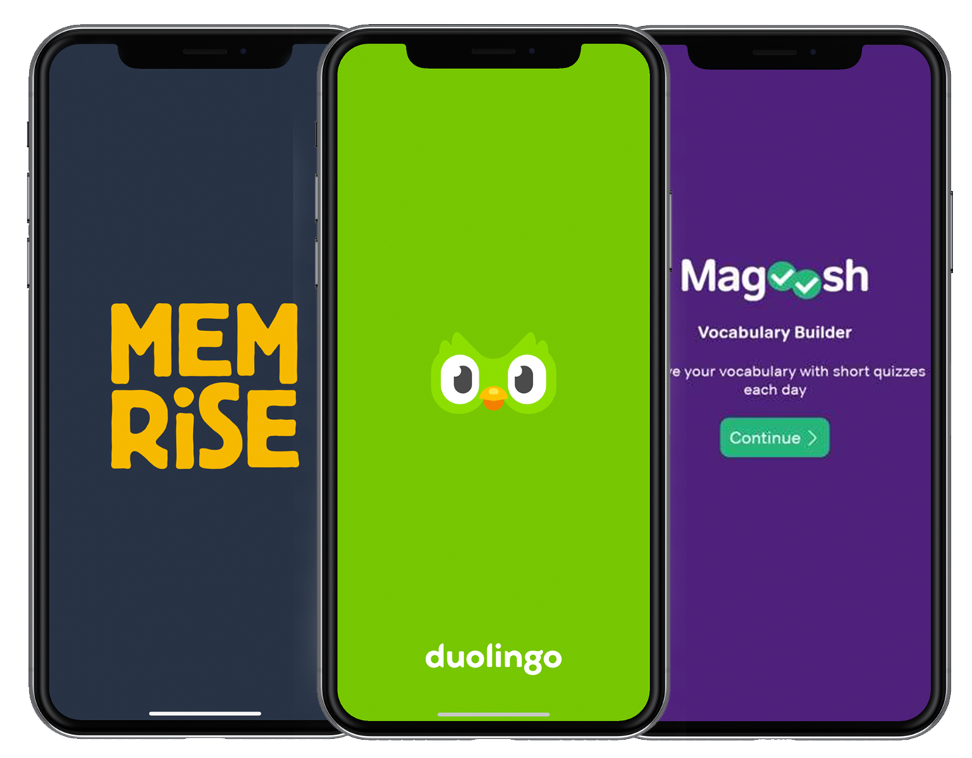

Mockup resource nr. 2

The focus of the analysis lied on attributes like how easy the apps are to use and whether the features of the apps accomplish the goals of its users. This analysis gave me inspiring insights and generated ideas which I used as a basis for the definition of app features.

The following step encompassed conducting user interviews with prospective users of the target audience identified. This brought me a deeper understanding of the users unique learning styles, what keeps them motivated and what their challenges and pain points were when learning a new language.

Persona creation

Armed with all this new information and inspirations, I created the proto persona – named Elisabeth. She represents the identified target audience in terms of behaviors, needs & goals. After defining her needs and goals, I defined a primary problem statement which will be tackled with possible design solutions.

Ein Bild, das Screenshot enthält.

Task Analysis & User Flows

With the main user goals at hand, next step was to create the user flows which will lead to completion of these goals. For this I had to define entry points and success criteria to consequently created two flows which I felt to be the most important ones for my persona.

Ein Bild, das Screenshot enthält.

Ein Bild, das Screenshot enthält.

Sketching & Wireframing

As a first step into sketching and wireframing I started with two rounds of idea generation using the [Crazy 8’s](https://designsprintkit.withgoogle.com/methodology/phase3-sketch/crazy-eights) technique. After I sorted out the best ideas of these sessions, I started to draw wireframes, representing the before created user flows. These wireframes then served as a basis for low-fidelity prototypes.

Prototyping & Testing

The hand drawn wireframes were integrated into a prototype using [Marvel app](https://marvelapp.com/). Unfortunately, I had problems setting up interactable areas within my wireframes (I reported this issue at Marvell’s service desk).

Ein Bild, das Text enthält.

First round wireframes for VoCa

Ein Bild, das Text enthält.

Second round wireframes for VoCa

I took this situation as a welcoming occasion for learning one of the major prototyping tools in the UX scene – [Adobe XD](https://www.adobe.com/at/products/xd.html). It took some time, but I’m sure that my dear test persons liked the fact that they can start using a nicely animated mid- to high fidelity prototype when I asked them to complete five usability test tasks.

Ein Bild, das Screenshot enthält.

Ein Bild, das Screenshot enthält.

Third round of wireframes for VoCa made with Adobe XD

The results of the usability tests gave me deep insight on what worked well and what still had to be improved – and to be honest what was not good at all.

Problems

Main problems that were revealed by the user tests were navigation issues and that users didn’t find the option to set the time duration when starting a new exercise. ​​​​​​​

Solutions

The navigation was enhanced by including back buttons and the exercise timer option moved from the profile page to the starting page of each new exercise.

Key takeaways

Doing user tests at the earliest stage possible will save a lot of work in the following work stages. Also, I learned that using colors within the wireframes in this project stage was not advisable because the wireframes themselves have to work without color guidance.

I really enjoyed all stages of this whole process. The way of asking open questions was a great learning experience – because by this and with consequent listening to the interview partner without unnecessary interruptions I got a lot of insights into their goals and challenges. After finishing the competitor analysis and user interviews the idea generation process in terms of featured services, was the most fun part though. I threw many of these ideas overboard and just sticked to the ones that were the most useful to my proto-persona Elisabeth.

I’m very much looking forward on getting into the next project and to learn new techniques, skills and tools.

Presentation

Besides you can see a short video of the work I have done for VoCa.

Also If you would like to give the prototype a try for yourself, please follow this [LINK](https://xd.adobe.com/view/cb034af0-8fb8-42f3-779f-fe8c6d023095-bd32/?fullscreen). If you have feedback for me, you are more than welcome to share it with me using the contact section on this website.

Resources

Mockups

1. https://www.mockupworld.co/free/man-looking-at-black-iphone-mockup/

2. https://www.mockupworld.co/free/front-view-iphone-x-mockup/

Symbols

https://thenounproject.com